Fire Detection and Alert System

A project submitted in partial fulfillment of the
requirements for the award of the degree of

Bachelor of Technology
in
INFORMATION TECHNOLOGY


Submitted by:
Dheeraj
Roll No:. 11912020
Branch: IT

Supervised by:
Dr. Mukesh Mann
Assistant Professor

Indian Institute of Information technology,
Sonepat -131201, HARYANA, INDIA

ACKNOWLEDGEMENTS
First of all, I am immensely indebted to Almighty God for his blessings and grace without which I could not have undertaken this task and my efforts would never have been a success.
I humbly consider it a privilege and honor to express my heartiest and profound gratitude to Prof Dr. Mukesh Mann, Assistant Professor -IT, and IIIT Sonepat, for his appropriate direction, valuable suggestion, under judging assistance so generously extended to me.
This guidance and support received from my entire classmates who contributed and who are contributing to this project, is vital for the success of this project. I am grateful for their constant support and help.
I also owe a sense of gratitude to my parents for encouragement and support throughout the project.

Dheeraj

Plagiarism Report
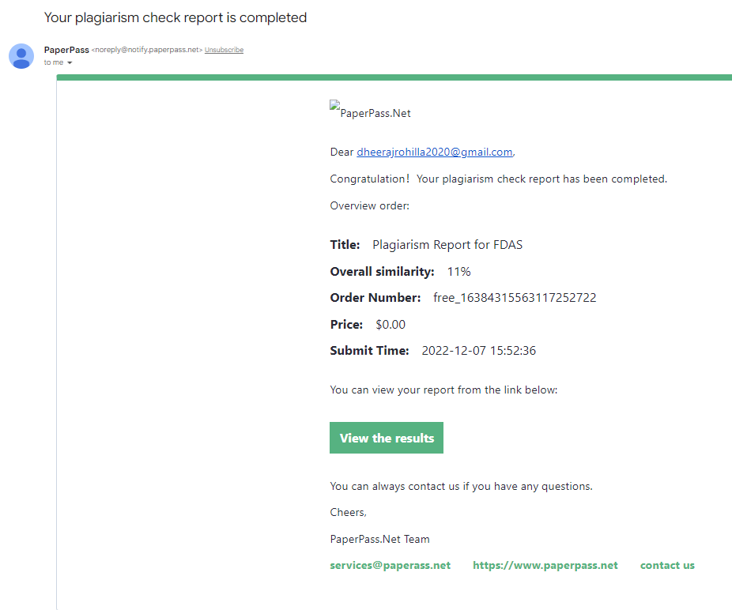

SELF DECLARATION
I hereby declare that the work contained in the project titled “Fire Detection and Alert System” is original. I have followed the standards of project ethics to the best of my abilities. I have acknowledged all sources of information that I have used in the project.

Name: Dheeraj
Roll No.: 11912020
Branch: IT
Department of Information Technology,
Indian Institute of Information Technology,
Sonepat-131201, Haryana, India.

CERTIFICATE
This is to certify that Dheeraj has worked on the project entitled “Fire Detection and Alert System” under my supervision and guidance.
The contents of the project, being submitted to the Information Technology, IIIT Sonepat, for the award of the degree of B.Tech in Information Technology, are original and have been carried out by the candidate himself. This project has not been submitted in full or part for the award of any other degree or diploma to this or any other university.

Dr. Mukesh Mann
Supervisor

Department of Information Technology,
Indian Institute of Information Technology,
Sonepat-131201, Haryana, India

ABSTRACT

Name of the student - Dheeraj, Roll No. 11912020, Degree for which submitted B.Tech (IT)., Department of Information Technology, IIIT, Sonepat.
Project Title: Fire Detection and Alert System
Name of the thesis supervisor: Dr. Mukesh Mann
Month and year of the project submission: December 2022

The project aimed to detect fire by using the deep learning that will alert people by early detection of fire. As there are many automatic fire alarm systems already existed like the sensor method, that has some limitations and designed to sense fire with the smoke, limited areas. To reduce limitations and to optimize with new technology, the project is proposed.
The project is implemented Fire Detection and Alert System. Webcam is taken as an input source, which captures the video feed from the surrounding and feeds into model. The entire code will be written in pure python language using deep learning libraries. This software will detect fire and alert the user about it by sending messages, sending email and making phone calls.
The project gives a better understanding of object detection with the computer and the use of these technologies in different forms and uses.

LIST OF ABBREVIATIONS
FDAS | Fire Detection and Alert System
S/W | Software
AI | ARTIFICIAL INTELLIGENCE
ML | MACHINE LEARNING

LIST OF FIGURES
Figure’s No. | Name of Figures | Page Nos.
Fig 1.1 | The Sashimi Model | 05
Fig 2.1 | Activity Diagram | 07
Fig 2.2 | Data Flow Diagram | 08
Fig 2.3 | Use Case Diagram | 08
Fig 2.4 | Star Uml Logo | 09
Fig 2.5 | Python Logo | 09
Fig 2.6 | Pycharm | 10
Fig 2.7 | Github Logo | 10
Fig 3.1 | Tensorflow | 12
Fig 3.2 | Keras | 12
Fig 3.3 | Matplotlib | 13
Fig 3.4 | Numpy | 13
Fig 3.5 | OpenCV | 13
Fig 3.6 | Convolutional Layer | 14
Fig 3.7 | Pooling Layer | 14
Fig 3.8 | Inception-V3 | 15
Fig 3.9 | Accuracy and Loss Graph | 17
Fig 4.1 | Black-Box Testing | 20
Fig 4.2 | White-Box Testing | 20

Acknowledgments……………………………….................................... | i
Plagiarism Report ……………………………………………………… | ii
Self-Declaration…………………………………................................... | iii
Certificate…………………………….................................................... | iv
Abstract……………………………....................................................... | v
List of Abbreviations…………………………….................................. | vi
List of Figures……………………………............................................. | vii
List of Tables…………………………….............................................. | viii

 | TABLE OF CONTENTS
CHAPTER 1 | INTRODUCTION |  |  | 01-06
 | 1.1 | Introduction……………….……............................ |  | 01-02
 | 1.2 | Motivation……………….…………….................. |  | 02-02
 | 1.3 | Problem Statement………………………………... |  | 02-02
 | 1.4 | Objectives………....………………………………. |  | 02-02
 | 1.5 | Application…………............................................... |  | 03-04
 | 1.6 | Project Methodology ………................................. |  | 04-05
 | 1.7 | Organization of project…………….…................. |  | 06-06
 | 1.8 | Summary…………………….………………....... |  | 06-06
CHAPTER 2 | DESIGN |  | 07-11
 | 2.1 | Introduction |  | 07-07
 | 2.2 | Diagrams |  | 07-08
 |  | 2.2.1 Activity Diagram |  | 07-07
 |  | 2.2.2 Data Flow Diagram |  | 08-08
 |  | 2.2.3 Use Case Diagram |  | 08-08

 | 2.3 | Development Platform Tools | 09-10
 | 2.4 | Summary | 11-11
CHAPTER 3 | IMPLEMENTATION |  | 12-18
 | 3.1 | Introduction | 12-12
 | 3.2 | List of libraries used | 12-13
 | 3.3 | The architecture of Inception-V3 | 14-16
 | 3.4 | Some Graphs Generated | 16-17
 |  | 3.4.1 Accuracy Graph | 16-16
 |  | 3.4.2 Loss Graph | 17-17
 |  | Some Features of Fire Detector | 17-18
 | 3.6 | Summary | 18-18
CHAPTER 4 | Testing and Validation |  | 19-23
 | 4.1 | Software Testing - Validation Testing | 19-19
 | 4.2 | Software Verification | 19-19
 | 4.3 | Manual and Automated Testing | 19-19
 | 4.4 | Testing Approaches | 20-21
 |  | 4.4.1 Black-Box Testing | 20-20
 |  | 4.4.2 White-Box Testing | 20-21
 | 4.5 | Test Summary | 21-21
 | 4.5 | Testing Technique used for FDAS | 21-21
 | 4.6 | Fail Case | 21-21
 | 4.7 | Summary | 22-22
CHAPTER 5 | Conclusion and Future Scope |  |  | 23-23
 | 5.1 | Conclusion | 23-23
 | 5.2 | Future Scope | 23-23
 | 5.3 | Limitation | 23-23
 | REFERENCES |  | 24-24
 | Appendix |  | 25-25

CHAPTER 1
INTRODUCTION
  - INTRODUCTION –

Fire is very dangerous that brings great loss of life and properties. Yearly thousands of accidents related to fire happen all over the world due to power failure, accidental fire, natural lightning. Fire accidents pose a serious threat to industries, crowded events, social gatherings, and densely populated areas that are observed across India. These kinds of incidents may cause damage to property, environment, and pose a threat to human and animal life. According to the recent National Risk Survey Report, Fire stood at the third position overtaking corruption, terrorism, and insurgency thus posing a significant risk to our country’s economy and citizens. The recent forest-fires in Australia reminded the world, the destructive capability of fire and the impending ecological disaster, by claiming millions of lives resulting in billions of dollars in damage. So, to control fire, various system is developed and being developed. The existing systems are the smoke sensors types and sprinkler type systems that detect fire from smoke and designed to activate after reaching the threshold set temperature. Still, with this kind of system, there are many disadvantages like a false alarm, space coverage, signal transmission, and also the delay in a fire alarm. As smoke detectors are placed in the ceiling, smokes take time to reach up to the ceiling, which results in time delay. And another problem of the existed system is tough to implement in the open environment and large infrastructures like stadiums, aircraft hangers due to the vast area covered by these infrastructures. Using the image processing technology in fire detection opens many possibilities. The technology can implement in hazardous areas where the heat and temperature are very high, and there is always a chance of getting fire. Those places should be monitored continuously because of the high-risk zone with this technology. The system can give the right information about the site.

The importance of the proposed thesis is to make a reliable, safe, and smart system to reduce limitations and faults like false alarms, which cause panic among the people and even the loss of money with the use of new technology. And make the places safe from the hazardous fire.

The project aimed to detect fire by using the deep learning that will alert people by early detection of fire. As there are many automatic fire alarm systems already existed like the sensor method, that has some limitations and designed to sense fire with the smoke, limited areas. To reduce limitations and to optimize with new technology, the project is proposed.
The project is implemented Fire Detection and Alert System. Webcam is taken as an input source, which captures the video feed from the surrounding and feeds into model. The entire code will be written in pure python language using deep learning libraries. This software will detect fire and alert the user about it by sending messages, sending email and making phone calls.
The project gives a better understanding of object detection with the computer and the use of these technologies in different forms and uses.

  - Motivation –

Fire accidents pose a serious threat to industries, crowded events, social gatherings, and densely populated areas that are observed across India. These kinds of incidents may cause damage to property, environment, and pose a threat to human and animal life. According to the recent National Risk Survey Report, Fire stood at the third position overtaking corruption, terrorism, and insurgency thus posing a significant risk to our country’s economy and citizens. Early detection of fire-accidents can save innumerable lives along with saving properties from permanent infrastructure damage and the consequent financial losses. In order to achieve high accuracy and robustness in dense urban areas, detection through local surveillance is necessary and also effective.

  - Problem Statement –

Human emotions and intentions are expressed through facial expressions and deriving an efficient and effective feature is the fundamental component of facial expression system. Face recognition is important for the interpretation of facial expressions in applications such as intelligent, man-machine interface and communication, intelligent visual surveillance, teleconference and real-time animation from live motion images. The facial expressions are useful for efficient interaction Most research and system in facial expression recognition are limited to six basic expressions (joy, sad, anger, disgust, fear, 3 surprise). It is found that it is insufficient to describe all facial expressions and these expressions are categorized based on facial actions [7]. Detecting face and recognizing the facial expression is a very complicated task when it is a vital to pay attention to primary components like: face configuration, orientation, location where the face is set.

1.4. Objectives -
- To Detect Fire with Good Accuracy
- Train model on large Dataset
- Send email after detecting the fire
- Call the Owner of Shop/Home after detecting the fire
- Send message after detecting the fire

1.5. Applications -
A Fire detection unit is one of the best fire protection/prevention equipment one can have. The equipment works as an alarm system that sounds when smoke is detected. Irrespective of how big or small your business is it is crucial that your building possess a fire alarm system.
The stringent safety codes of the National Fire Protection Association (NFPA) that cover everything on how the fire alarms signal danger as to what kind of chemicals and additives can be used in an extinguishing system and so on. The fire laws are nationally mandated but locally enforced. It is often a requirement for the insurance companies that you comply by these standards. It can be very frustrating complying to the regulations however, getting in the right professionals helps ease the stress and ensures the system is properly installed.
Safety Benefits
The main advantage and function of a fire alarm system is to ensure ultimate safety. They help warn and keep people safe and reduce the amount of destruction to a building.
- Life Safety: This is probably the major reason as to why a business will install a fire detection system. A high quality and advanced fire detection and alarm system will be able to warn the employees of a building that they need to get out of the building when a fire is starting and where the fire is in the building.
- Property Safety: Fire detection systems increase response times, as they are able to alert the correct people in order to extinguish the fire. This thus reduces the amount of damage to the property. Fire detection systems can be connected to sprinklers that will automatically respond when a fire is detected.
Quicker Response Times
The smoke detector system will be connected to a loud alarm system that will be set off when a fire has been detected. This will then alert the people in the building to exit and it will also alert the service provider who will then alert the emergency services. As a result, fire fighters will be immediately dispatched to the business the moment a fire is detected by the system.
Minimisation of Costs
It may not look like it at first with the initial upfront investment that can be substantial, however, over the long run a well maintained and tested commercial fire detection system can lower your insurance cost thus lowering your overhead cost and one will not face fines during their inspections for not have a sufficient system in place.

Integration of Systems
There are some instances that some buildings require access control systems. This advanced fire detection system is beneficial when these systems are interconnected. When these systems are integrated the fire detection system can disable the access control system and thus enabling people to exit the building faster and safer.
Minimisation of Unnecessary Business Interruptions
There can be a problem when a business has a faulty fire alarm system that can be set off when there is no fire present and therefore causing interruptions of the business and resulting in being costly to the company. With a high quality, well installed and well-maintained fire detection system this minimises or even erases the unnecessary business interruptions.
Self-Monitoring System and Alert System
One of the benefits is that no human intervention is needed and this is because the fire detection system uses sensors to detect smoke. With no human monitoring needed this gives the benefit the system of providing a warning that there is a fire even though there might be no one in the building.
1.6 PROJECT METHODOLOGY –

All the objectives mentioned above are going to be achieved with the help of the SASHIMI model.

The first objective i.e., Live Fire Detection: To identify the fire and alert the owner about it with the help of computer vision and deep learning.

Our second objective is to maximize Accuracy: To achieve maximum accuracy on detection to do this we are going to take the data set as big as possible

Out third objective is to send email to the user and 4th objective to make phone calls to the owner and last objective is to send message to the owner

In this project, the changing of requirements is required and we are going to overlap the different S/W phases over each other. All the resources for the project are available to us and we wanted the project to get started soon, moreover, we wanted to shorten our time scale that’s why we used this model.

3 Months 6 Months 9 Months
Fig 1.1 THE SASHIMI MODEL
Advantages of using the SASHIMI Model in this project-
- Shortens the development time, as different S/W layers are overlapped over each other.
- A 12-month project could be done in 9 months.
- People with different skills can start working on the project without waiting for the work done for the previous phase.
- The architect can start working on the project before even the analyst or who is doing the requirements is done.
Disadvantages of using the SASHIMI Model in this project-
- It may result in some rework because the design phase is started before all the requirements were done.
- It means that if something is found later, during the requirement phase, the design phase is then again needed to be adjusted.
If the coding phase is already started, then that requirement change may also result in some rework.

1.7 THE ORGANISATION OF PROJECT
- In Chapter 1, a brief Intro, problem outline, project objectives, methodology, the scope of FDAS are discussed.
- In Chapter 2, the Study Design of FDAS will be discussed.
- In Chapter 3, Implementation will be discussed– a tool used in the development of this project.
- In Chapter 4, Software testing and validation will be discussed.
- In Chapter 5, the Conclusion and Future of this Project will be discussed.

1.8 SUMMARY
In this chapter, A brief introduction to Fire Detector is given. Nowadays, Fire is very dangerous that brings great loss of life and properties. Yearly thousands of accidents related to fire happen all over the world due to power failure, accidental fire, natural lightning. One of the many important aspects of a software is the ability to detect Fire Detector and alert the owner to provide safety and security and prevent loss of life and property.

After that, the problem outline is discussed with the purpose of the project, its goals, and its description which tells about why we selected this project.

Project Objectives are discussed afterward which are Live Fire Detector, achieving Max Accuracy, and Reducing Accidents by taking large data set as much as possible.

Project Methodologies are also discussed to achieve the above-mentioned objectives in the future. THE SASHIMI MODEL will be used in the project methodology.

Further future scopes for Fire Detector are also discussed in this chapter. The aim is to implement this software in the shops, hospital and houses.

The organization of the project is discussed at the end in which a brief intro of all the chapters have been given.

CHAPTER - 2
DESIGN
2.1 Introduction –
Fire Detector and Alert System will be used to detect fire and alert the user about it by sending email, messages and making phone calls. In this chapter, we will be discussing general components for FDAS and designing parts like Development Platform tools used, Use Case Diagrams, Data Flow Diagrams, Activity Diagrams. At last, We Give a Summary of this Design Chapter.
  - Diagrams -
    - Activity Diagram:
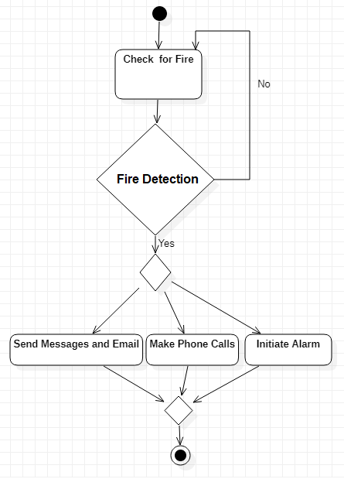
Fig 2.1 Activity Diagram
    - Data Flow Diagram:
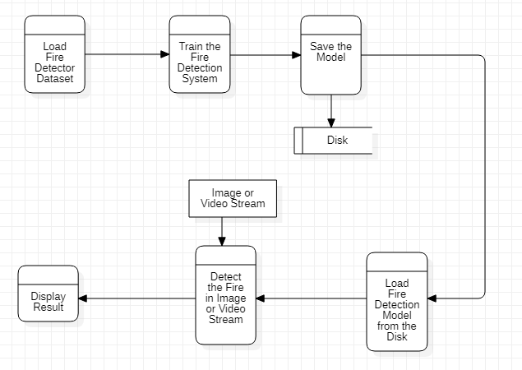
Fig 2.2 Data Flow Diagram
    - Use Case Diagram:

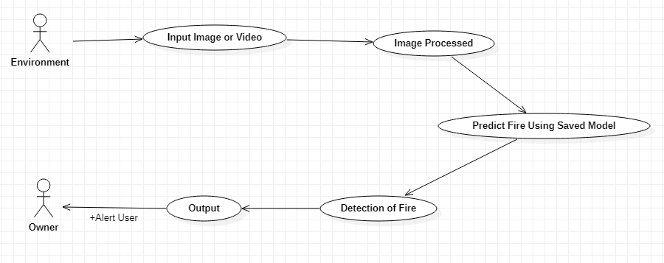
Fig 2.3 Use Case Diagram

  - DEVELOPMENT PLATFORM-TOOLS –

The following development tools are needed for the development of this project
1. Star Uml for Developing Various Diagrams related to this project.
2. Python, as the programming language.
3. PyCharm Notebook for Coding purpose.
4. GitHub for collaboration purposes.
1) STAR UML -


FIG 2.7 STAR UML

StarUML is a sophisticated software modeler for agile and concise modeling. It is compatible with many UML diagrams.

2) PYTHON LANGUAGE –


FIG 2.8 PYTHON

Python is an interpreted, high-level, and general-purpose programming language. Its overall code written code is very less as compare to other programming languages.

3) PyCharm -



FIG 2.9 PyCharm IDE

PyCharm is an Integrated Development Environment (IDE) used for programming in Python. It provides code analysis, a graphical debugger, an integrated unit tester, integration with version control systems, and supports web development with Django. PyCharm is developed by the Czech company JetBrains.
It is cross-platform working on Windows, Mac OS X and Linux. PyCharm has a Professional Edition, released under a proprietary license and a Community Edition released under the Apache License. PyCharm Community Edition is less extensive than the Professional Edition.
4) GITHUB –



FIG 2.10 GITHUB

GitHub, Inc. is a subsidiary of Microsoft which provides hosting for software development and version control using Git. It provides access control and several collaboration features such as bug tracking, feature requests and many more.

  - SUMMARY –

This chapter talks about the design part of the Fire Detection and Alert System. The working of FDAS is also discussed in this chapter. General components of FDAS.

This chapter also talks about the system Design of FDAS in which a brief discussion is there for the total design of the FDAS.

The total design consists of two phases: training and testing

Then a brief discussion of the Data Flow Diagram, Activity Diagram, and Use Case Diagram is also there which tells the depth working of FDAS.

In the end, development tools used in FDAS are discussed.

CHAPTER - 3
IMPLEMENTATION
  - INTRODUCTION
Implementation i.e., how FDAS is implemented is discussed in this chapter.

  - List of Libraries Used:
- TensorFlow: TensorFlow provides a collection of workflows to develop and train models using Python or JavaScript.


Fig 3.1

- Keras: Keras is an API designed for human beings, not machines. Keras follows best practices for reducing cognitive load it offers consistent & simple APIs, it minimizes the number of user actions required for common use cases, and it provides clear & actionable error messages. It also has extensive documentation and developer guides.

Fig 3.2

- Matplotlib: Matplotlib is a comprehensive library for creating static, animated, and interactive visualizations in Python.
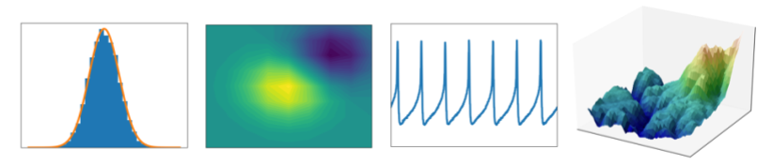
Fig 3.3

- NumPy: NumPy is a Python library used for working with arrays. It also has functions for working in the domain of linear algebra, Fourier transform, and matrices.

Fig 3.4
- Open-cv: OpenCV-Python is the Python API for OpenCV, combining the best qualities of the OpenCV C++ API and the Python language.


Fig3.5

- Imutils: A series of convenience functions to make basic image processing functions such as translation, rotation, resizing and many more.

3.3 The Architecture of Inception V3 -

1) Convolutional Layer
The convolutional layer is the primary process underlying CNN. The Convolutional layer consists of neurons arranged in such a way as to form a filter with length and height (pixels). The purpose of convolution in image data is to extract features from the input image. Convolution will produce linear transformations of input data according to spatial information on the data.

Fig. 3. Convolutional layer

There is an input image with a 4x4 size as illustrated in Fig. 3, and the convolution process will be carried out with a 2x2 filter with stride 1.
1. Convolution result = (1x1) + (2x1) + (2x0) + (2x1) = 5
2. Convolution result = (2x1) + (2x1) + (1x0) + (2x1) = 6
This convolution process continues, until the last pixel in the lower corner of the input.

2) Pooling Layer

The purpose of this pooling layer is to divide the convolution layer's output into several small grids and then take the maximum value from each grid to compile the reduced image matrix. The pooling layer's function is to reduce the number of parameters and reduce the complexity of the convolution layer [11]. In the pooling layer, the most widely used method is max-pooling, which takes the most significant value from the convolution layer, such as Fig. 4.

Fig. 4. Pooling layer [12]
3) Fully Connected Layer
The last layer of CNN, the Fully Connected Layer, can combine all the specific features detected by the previous layer in the input data. The Fully-Connected layer can store the earlier layers' results and save them in vector form [12].

4) Inception-v3
The main difference between the Inception models and regular CNNs are the inception blocks. These involve convolving the same input tensor with multiple filters and concatenating their results. In this paper, we use Inception-v3 (see Fig. 5) with 42 layers deep, and the computation cost is only about 2.5 higher than that of GoogLeNet [13] and much more efficient than that of VGGNet [14].
Fig. 5. Inception-v3 architecture [15]

E. Testing Box

Fig. 6. Computer case box
Testing the system will use a box made of empty computer cases as shown in Fig. 6,. This box has a height of 20 cm, a width of 40 cm, length of 38 cm with the camera positioned at an angle of 50 degrees from the center point of the box.
IV. SYSTEM DESIGN AND OVERVIEW
This research uses HoG backpropagation and feature extraction architectures because of reducing loss and increasing accuracy. Steps for classifying fire are:
A. Labeling Data
Labeling here is meant to distinguish which one is fire and which is not fire. We currently use conditions 1 and 0, for fire and not fire as shown in Fig.7. The label will appear at the time of the prediction.
Fig. 7. Initialization of label.

The process of labelling an image is as follows. Each fire image will change the name of the file with 'fire-n,' and the non-fire image will be 'not_fire-n' then make the def labelling code. We have to label this data because it will make the computer know each image's information, which is needed for machine learning.
3.4 Some Graphs Generated
3.4.1 Accuracy Graph
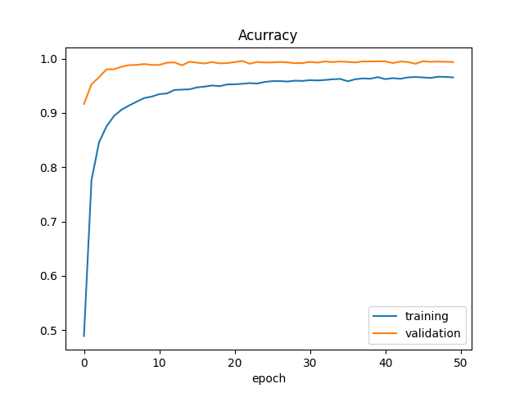

3.4.2 Loss graph
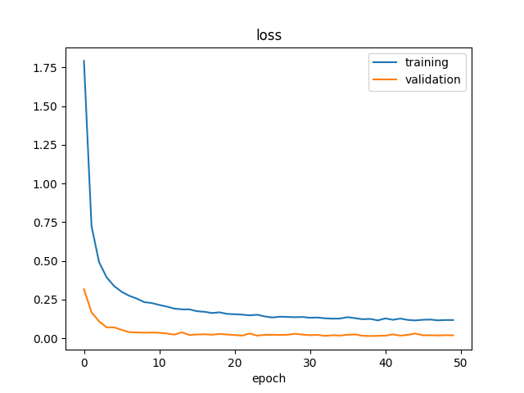

3.5 Some features of Fire Detector and Alert System: -

- Fire Detection

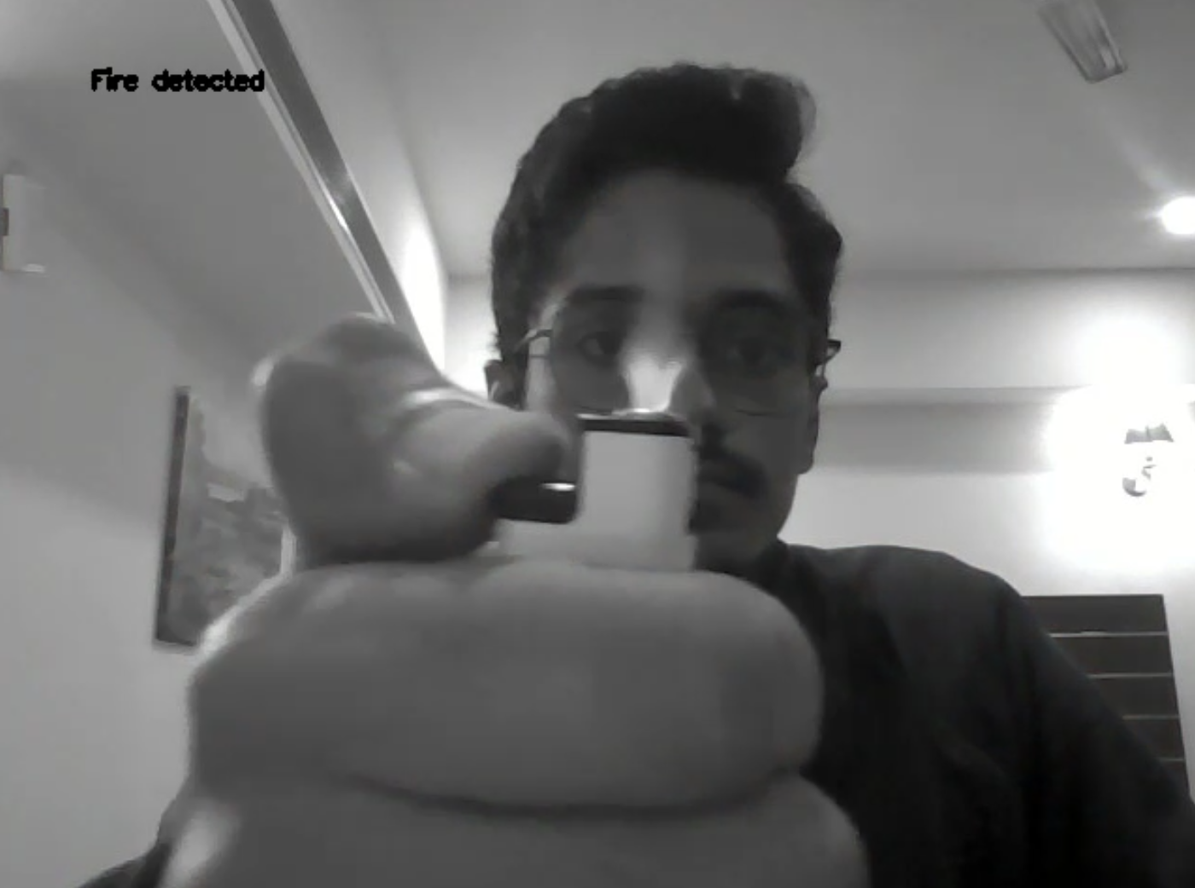

- Email Sending after detection of fire
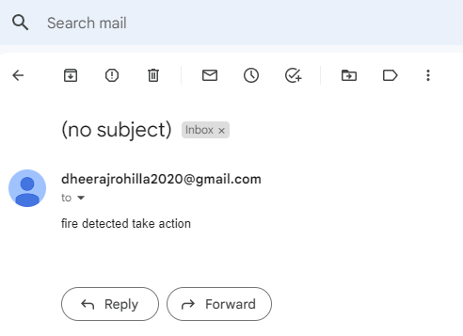
- Make Phone call to owner after detection of fire.
- Send message to owner after detection of fire.

3.6 SUMMARY – In this chapter, the implementation of FDAS is discussed. Some main features are also discussed.

CHAPTER – 4
TESTING AND VALIDATION

Software Testing - Validation Testing -
Validation is the process of examining whether or not the software satisfies user requirements. It is carried out at the end of the SDLC. If the software matches the requirements for which it was made, it is validated.
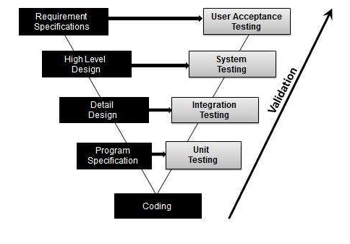

Software Verification -
Verification is the process of confirming if the software is meeting the business requirements, and is developed adhering to the proper specifications and methodologies.

Manual Vs Automated Testing

4.3 Testing can either be done manually or using an automated testing tool:
- Manual - This testing is performed without taking the help of automated testing tools. The software tester prepares test cases for different sections and levels of the code, executes the tests, and reports the result to the manager.
- Automated This testing is a testing procedure done with aid of automated testing tools. The limitations of manual testing can be overcome using automated test tools.
There are software and hardware tools that help testers in conducting load testing, stress testing, regression testing.

4.4 Testing Approaches -
Tests can be conducted based on two approaches –
- Functionality testing
- Implementation testing

4.4.1 Black-box testing -
It is carried out to test the functionality of the program. It is also called ‘Behavioral’ testing. The tester, in this case, has a set of input values and respective desired results. On providing input, if the output matches with the desired results, the program is tested ‘ok’, and problematic otherwise.
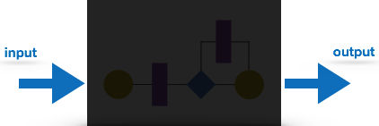
Fig 4.1 Black-Box Testing

White-box testing -
It is conducted to test the program and its implementation, in order to improve code efficiency or structure. It is also known as ‘Structural’ testing.

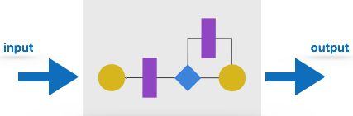
Fig 4.2 White-Box testing
The white box testing contains various tests, which are as follows:
- Path testing
- Loop testing
- Condition testing
- Testing based on the memory perspective
- Test performance of the program

Before Testing
Testing starts with test case generation. Following documents are needed for reference –
- SRS document
- Test Policy document
- Test Strategy document
- Traceability Matrix document

While Being Tested
The following documents may be required while testing is started and is being done:
- Test Case document
- Test Description
- Test case report
- Test logs
After Testing
The following documents may be generated after testing:
  - Test summary - This test summary is the collective analysis of all test reports and logs. It summarizes and concludes if the software is ready to be launched.

  - TESTING TECHNIQUE USED FOR FIRE DETECTION AND ALERT SYSTEM
Manual testing is done for this project as it was not possible to automate the testing for this project. Testing is done for the detection of various types of masks and different combinations
  - FAIL CASE: -
The one failure of the Fire Detector is it cannot work on the very low-quality camera.

  - SUMMARY –
Various software testing techniques are described in this chapter. Manual Testing is done for this project as automation for Fire Detector was not possible.

CHAPTER - 5
CONCLUSION AND SCOPE
5.1. Conclusion
The fire detection covers a very large field, and it would be impossible to cover all aspects in one project. The focus in this project is detection using a low-cost camera.
This would mean that the program does not only work with expensive technology such as infrared cameras or other such cameras. The cameras that are required to at least work with this program are the CCTV cameras, such as those in shopping complexes or malls. One factor that needs to be taken into consideration is that, unlike other fire detectors, this system is not a point type detector. It should be able to detect fire in large open spaces, so that the whole scenario must be considered, and not just a single point on the image from the video feed. A system that can also be used in aggressive environments as well as in hazardous areas.
5.2. Future Scope
The application can be enhanced by training the model with a larger dataset consisting of fires at various stages and dimensions. With higher GPU memory, we could use two deep learning models for feature extraction, whose output feature vectors are concatenated and classified to offer more robustness. An R-CNN model can be used to implement fire localization along with classification. We can also expect better deep learning architectures to emerge in the future, offering better feature extraction. The application will also offer a considerably better performance when run on machines having better processing power compared to existing one of which it has been developed.
5.3 Limitation
- Requires more training.
- Need descent quality camera.
- Sometime but rarely show incorrect result in sunset conditions
REFERENCES
5.4 REFERENCES

[1] Kompas News. (2018). Dry Season Expands BMKG Wary of Potential Forest and Land Fires [Online].
[2] SATU DATA INDONESIA (2018). Bandung City Fire Data in 2018 [Online].
[3] V. Tipsuwanpom , V. Krongratana S. Gulpanich and K. Thongnopakun “Fire Detection Using Neural Network” SICE-ICASE International Joint Conference 2006.
[4].Software Development models, accessed 1 October 2021, https://mohamadkoteich.com/2019/01/30/software-development-models/
[5] Dengyi Zhang, Shizhong Han, Jianhui Zhao, Zhong Zhang, Chengzhang Qu, Youwang Ke, Xiang Chen “Image-Based Forest Fire Detection Using Dynamic Characteristics With Artificial Neural Networks” 2009 International Joint Conference on Artificial Intelligence.
[6].Github ,accessed 1 October 2021, https://en.wikipedia.org/wiki/GitHub
[7].Software Process Models, accessed 1 October 2021, https://www.thomasalspaugh.org/pub/fnd/softwareProcess.html
[8] Cheryl Marlitta Stefia “Fire Detection System to Prevent Fire With Artificial Neural Network Method” Openlibrary-Telkom University 2018.
[9] Frizzi, S., Kaabi, R., Bouchouicha, M., Ginoux, J., Moreau, E., Fnaiech, F., “Convolutional Neural Network for Video Fire and Smoke Detection”, 2016
[10]. Keras, accessed 1 October 2021, https://en.wikipedia.org/wiki/Keras
[11]. StarUml, accessed 2 October 2021, https://en.wikipedia.org/wiki/StarUML
[12].Python, accessed 3 October 2021, https://en.wikipedia.org/wiki/Python_(programming_language)
[13]. OpenCv, accessed 3 October 2021, https://en.wikipedia.org/wiki/OpenCV
[14] Jupyter Notebook, accessed 4 October 2021, https://jupyter.org/
[15] Gurpreet Singh, Manoj Sachan "Multi-Layer Perceptron (MLP) Neural Network Technique for Offline Handwritten Gurmukhi Character Recognition," IEEE International Conference on Computational Intelligence and Computing Research, 2014

[16]. Unified Modeling Language (UML) | Activity Diagrams, accessed 1 October 2021, https://www.geeksforgeeks.org/unified-modeling-language-uml-activity-diagrams/

[17] Sevcan Aytaç Korkmaz, Ayesegül Akçiçek, Hamidullah BINOL, Mehmet Fatih Korkmaz "Recognition of the Stomach Cancer Images with Probabilistic HOG Feature Vector Histograms by using HOG Features," IEEE 15th International Symposium on Intelligent Systems and Informatics (SISY), 2017.

APPENDIX
GITHUB LINK- https://github.com/Dheeraj2000/Fire-Detection-and-Alert-System

